# 💻 Advanced Web Technologies – Lab Report

A collection of experiments exploring **HTML**, **CSS**, **JavaScript**, **jQuery**, and **Node.js (Express)** concepts.

## 📚 Table of Contents

1. Experiment 1 – Basic HTML & CSS
2. Experiment 2 – JavaScript DOM Manipulation
3. Experiment 3 – Form Validation / JS Logic
4. Experiment 4 – External JS & CSS Integration
5. Experiment 5 – jQuery Effects & DOM Traversal
6. Experiment 6 – Node.js Basics
7. Experiment 7 – Express Application
8. Cookies & Sessions in Node.js
9. Node.js Lab Programs
10. My Project

## Rick Project

## Experiment 1 – Basic HTML & CSS

**Files:** exp1/index.html, exp1/style.css

**Objective:**  
Create a simple static webpage using HTML and CSS.

**What I Learned:** - Structuring a webpage using HTML elements. - Linking and styling with external CSS. - Basics of layout, colors, and text formatting.

**Challenges Faced:**  
- Understanding CSS selectors and positioning elements properly. EXPERIMENT 1 HTML 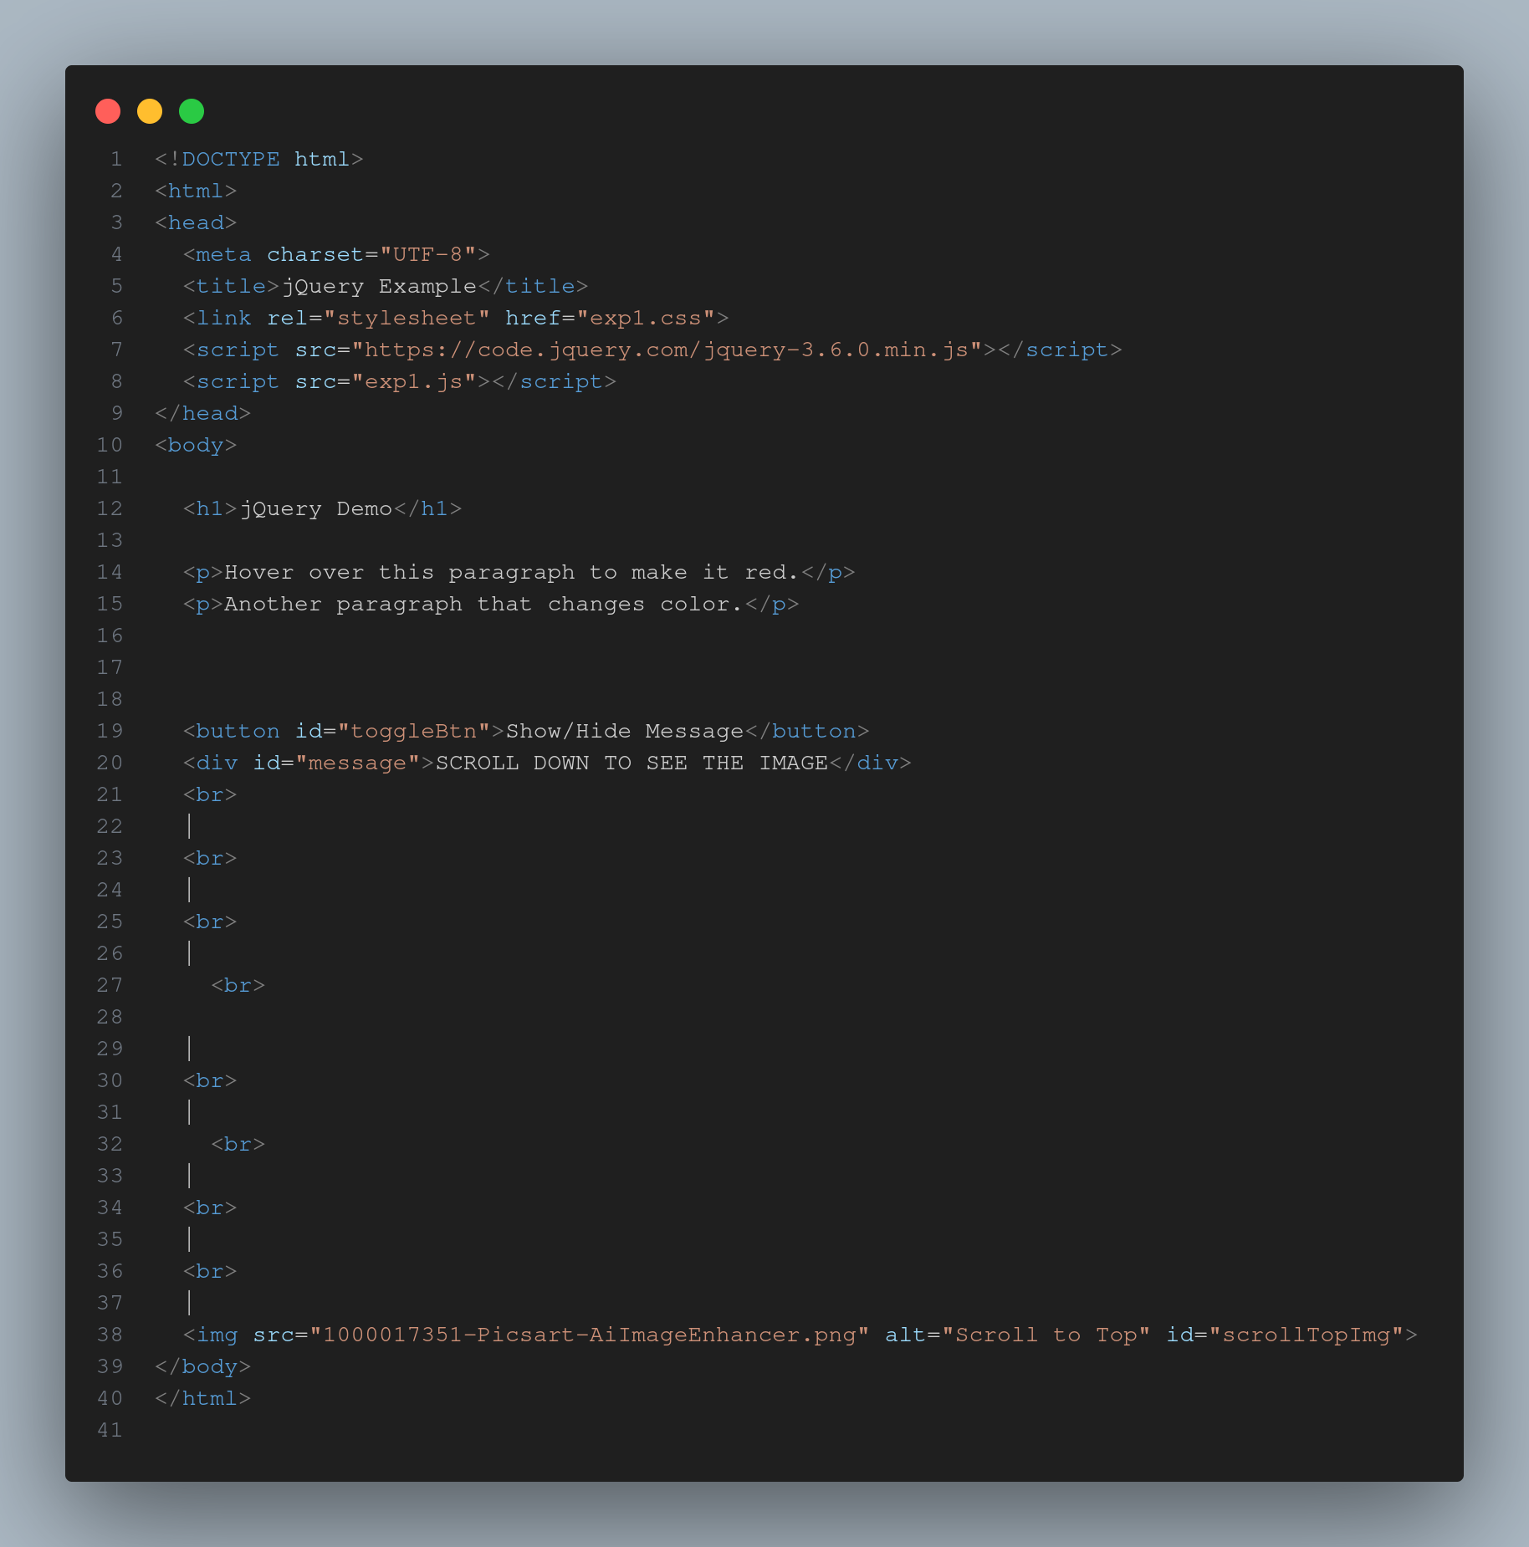 EXPERIMENT 1 CSS 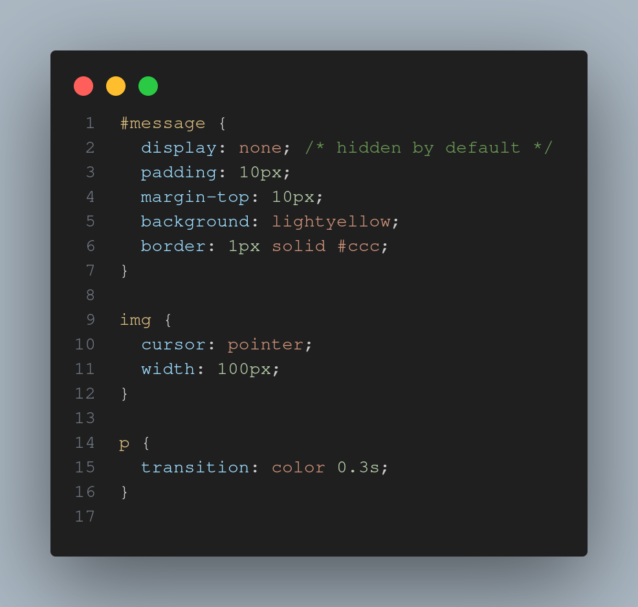 EXPERIMENT 1 JS 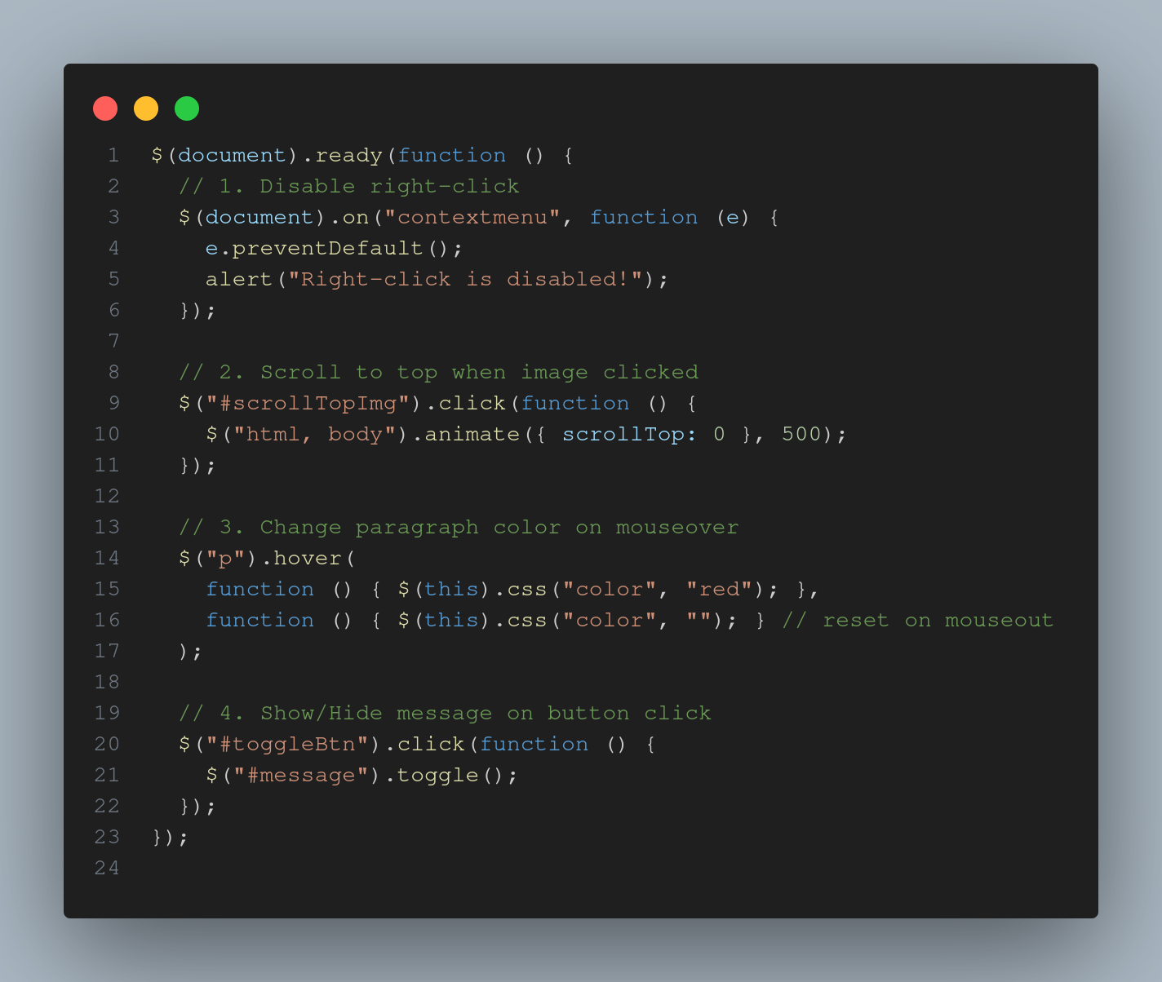 EXPERIMENT 1 OUTPUT 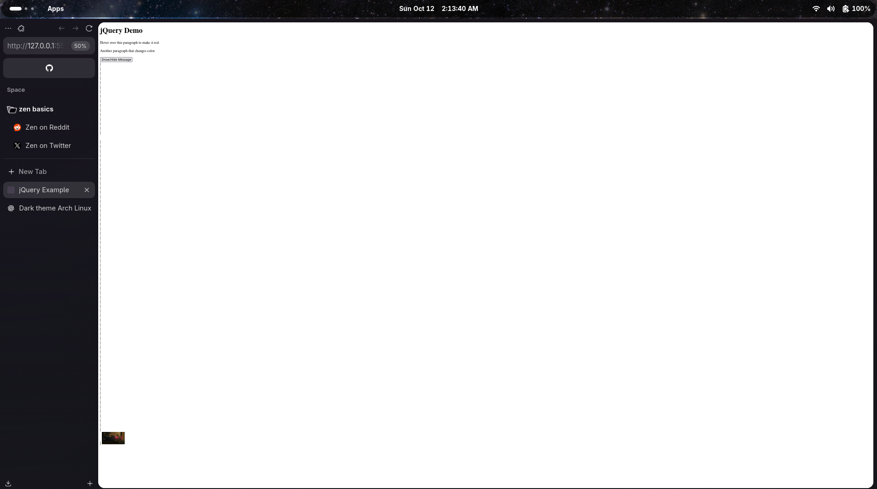 —

## Experiment 2 – JavaScript DOM Manipulation

**Files:** exp2/index.html, exp2/app.js

**Objective:**  
Perform DOM manipulations using JavaScript — changing content, reacting to events, etc.

**What I Learned:** - Accessing and modifying DOM elements. - Using getElementById() and querySelector(). - Handling events like onclick and onchange.

**Challenges Faced:**  
- Debugging event listeners and ensuring scripts loaded after DOM.

EXPERIMENT 2 HTML 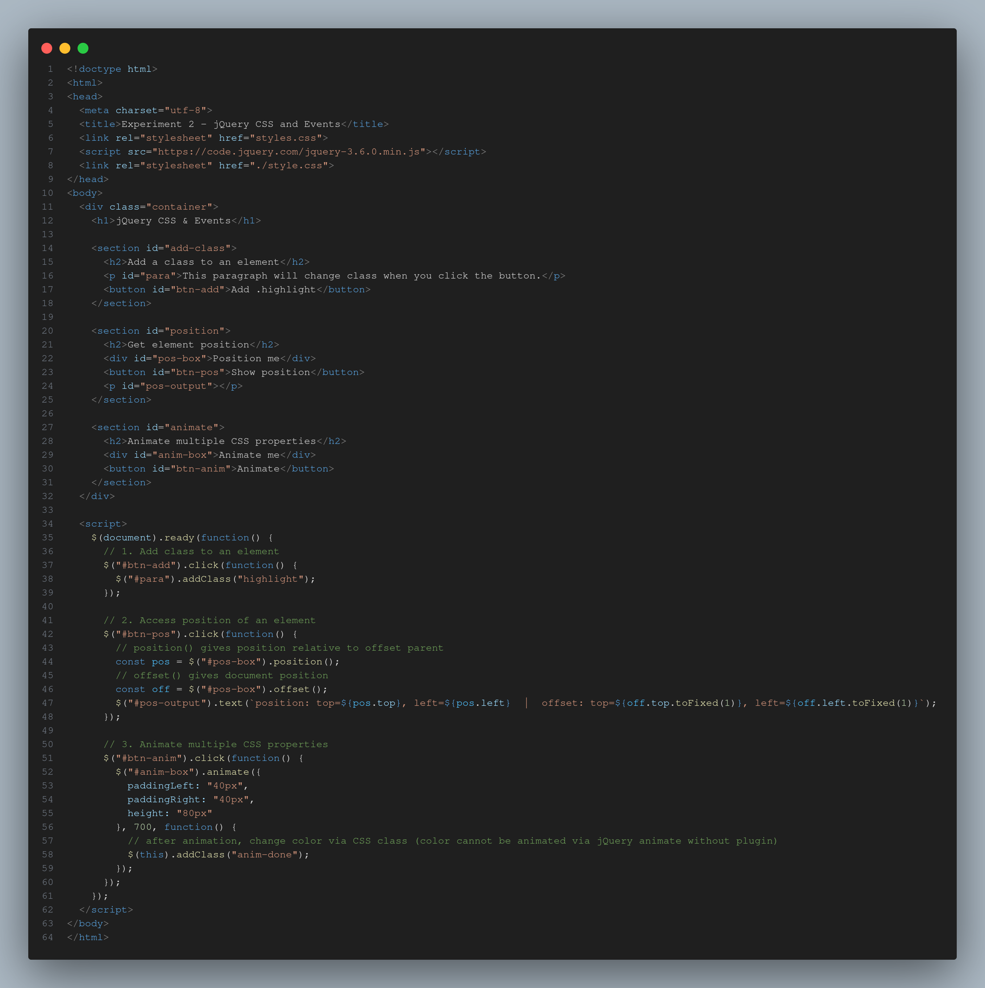 EXPERIMENT 2 CSS 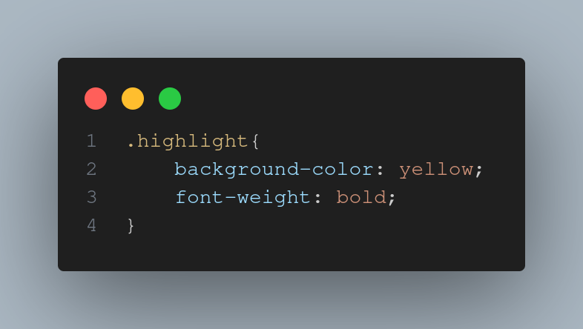 EXPERIMENT 2 OUTPUT 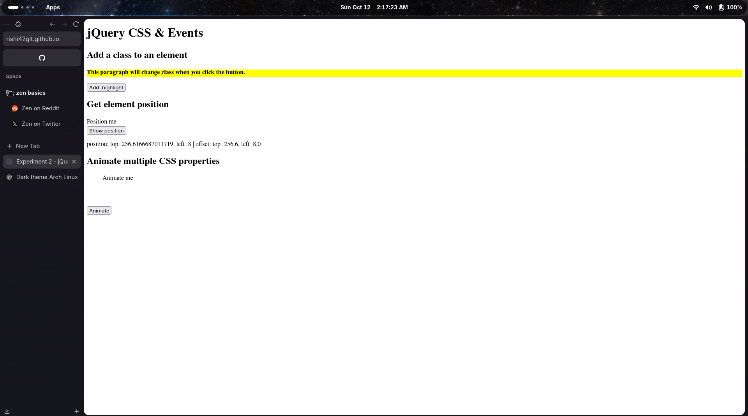 —

## Experiment 3 – Form Validation / JS Logic

**Files:** exp3/index.html, exp3/app.js

**Objective:**  
Validate user inputs in forms using JavaScript.

**What I Learned:** - Writing conditions and regex for input validation. - Showing alerts or inline error messages. - Managing user interaction dynamically.

**Challenges Faced:**  
- Preventing form submission when validation failed.

EXPERIMENT 3 HTML 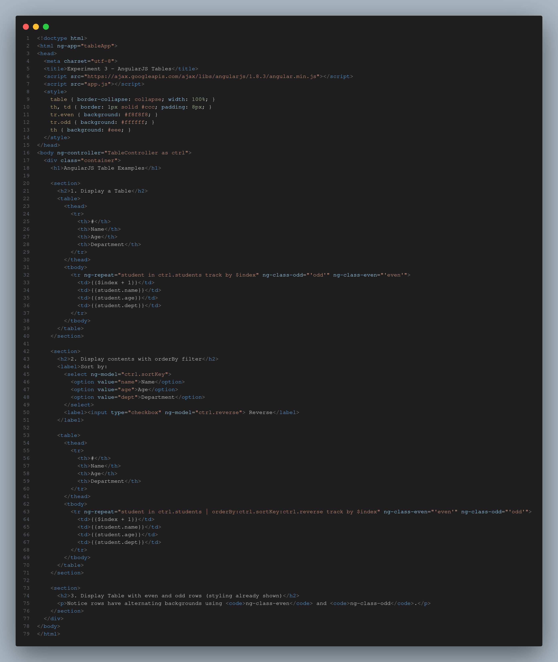 EXPERIMENT 3 CSS 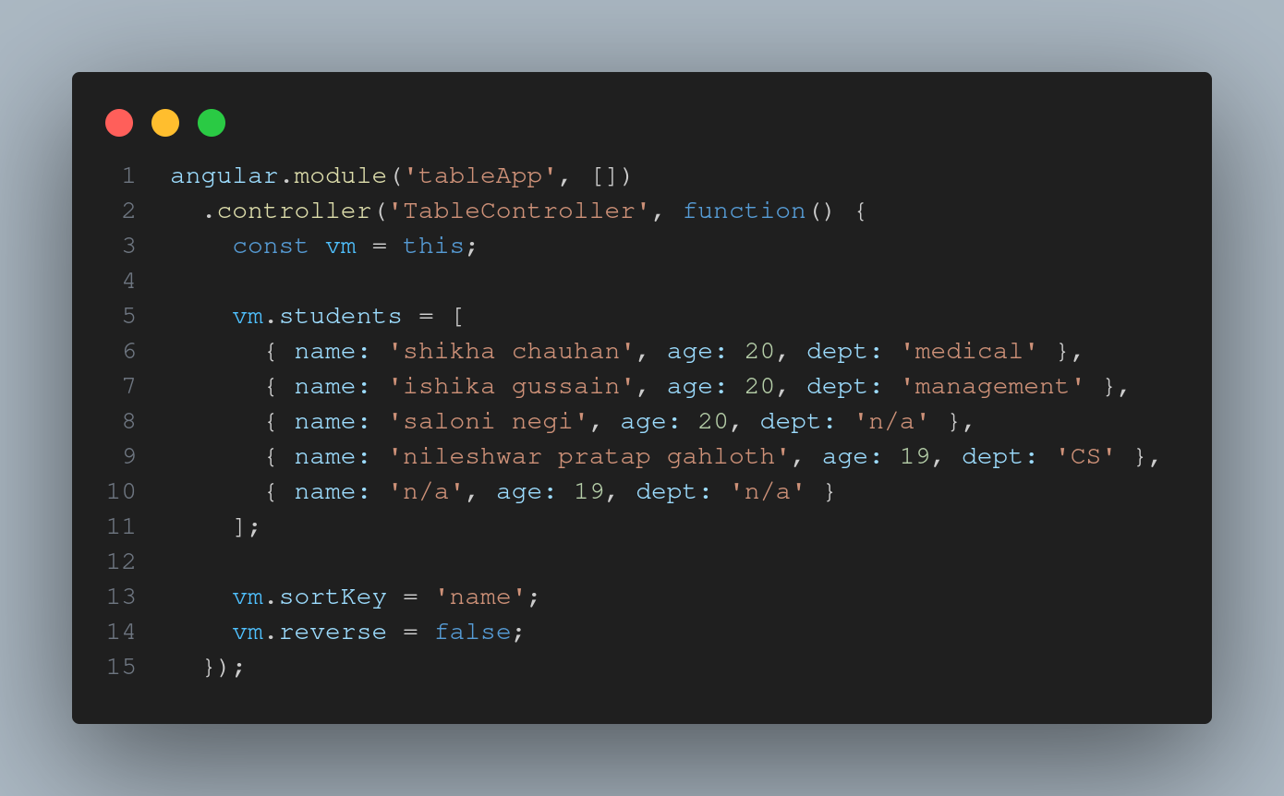 EXPERIMENT 3 OUTPUT 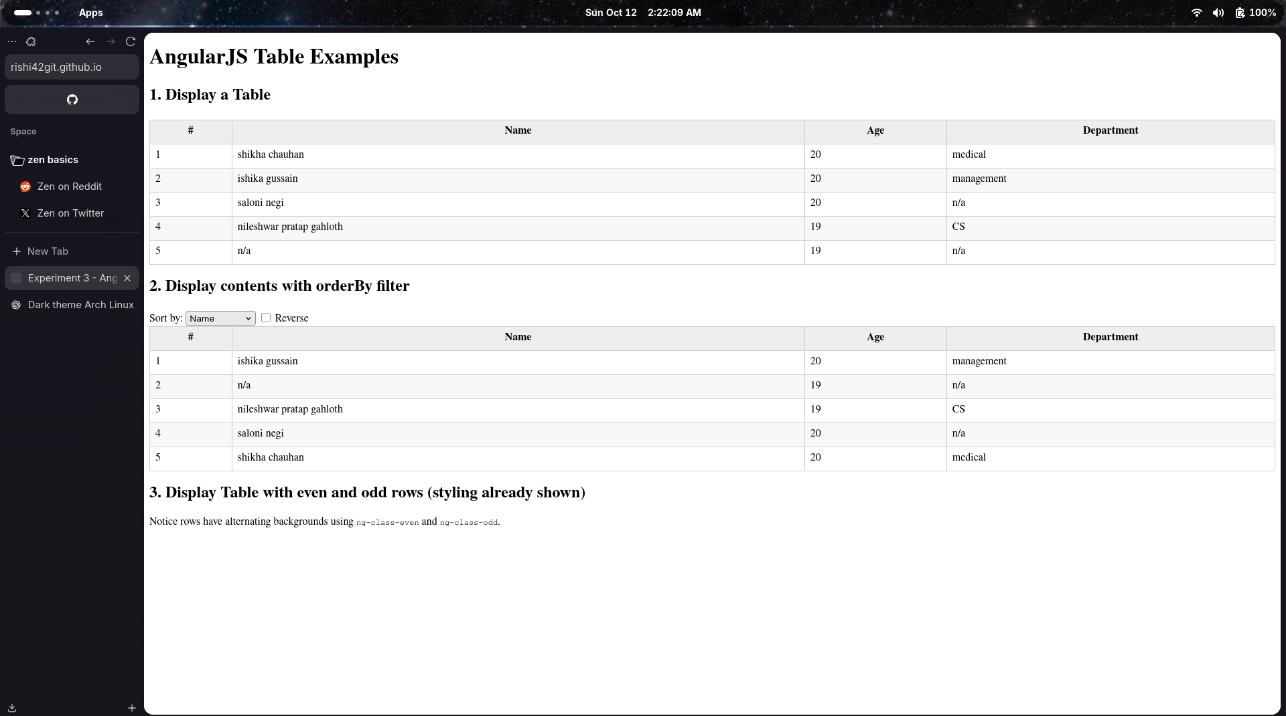 —

## Experiment 4 – External JS & CSS Integration

**Files:** exp4/index.html, exp4/exp4.css, exp4/exp4.js

**Objective:**  
Use modular coding by separating JS and CSS files.

**What I Learned:** - Linking multiple external resources. - Maintaining cleaner project structure. - Understanding script loading and CSS cascading.

**Challenges Faced:**  
- Handling file paths and ensuring all resources loaded correctly. bill payment record EXPERIMENT 4 HTML 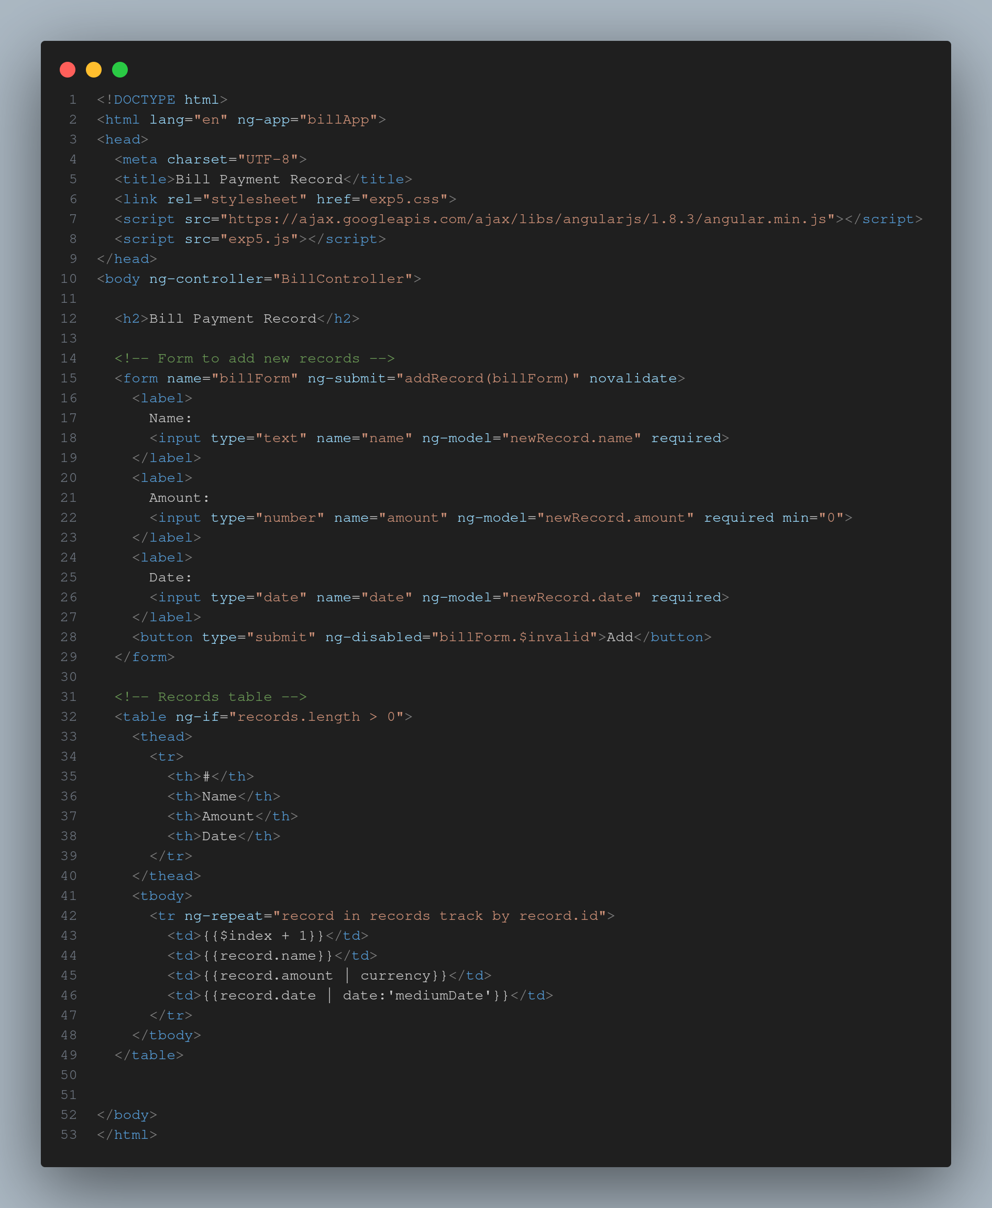 EXPERIMENT 4 CSS 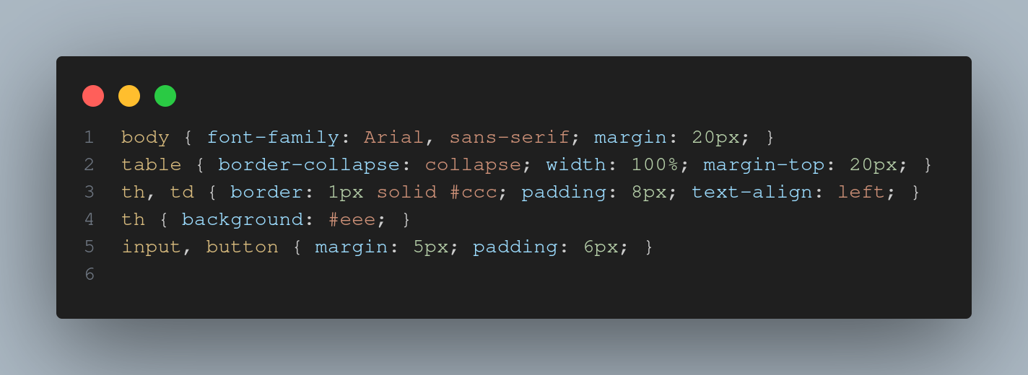 EXPERIMENT 4 JS 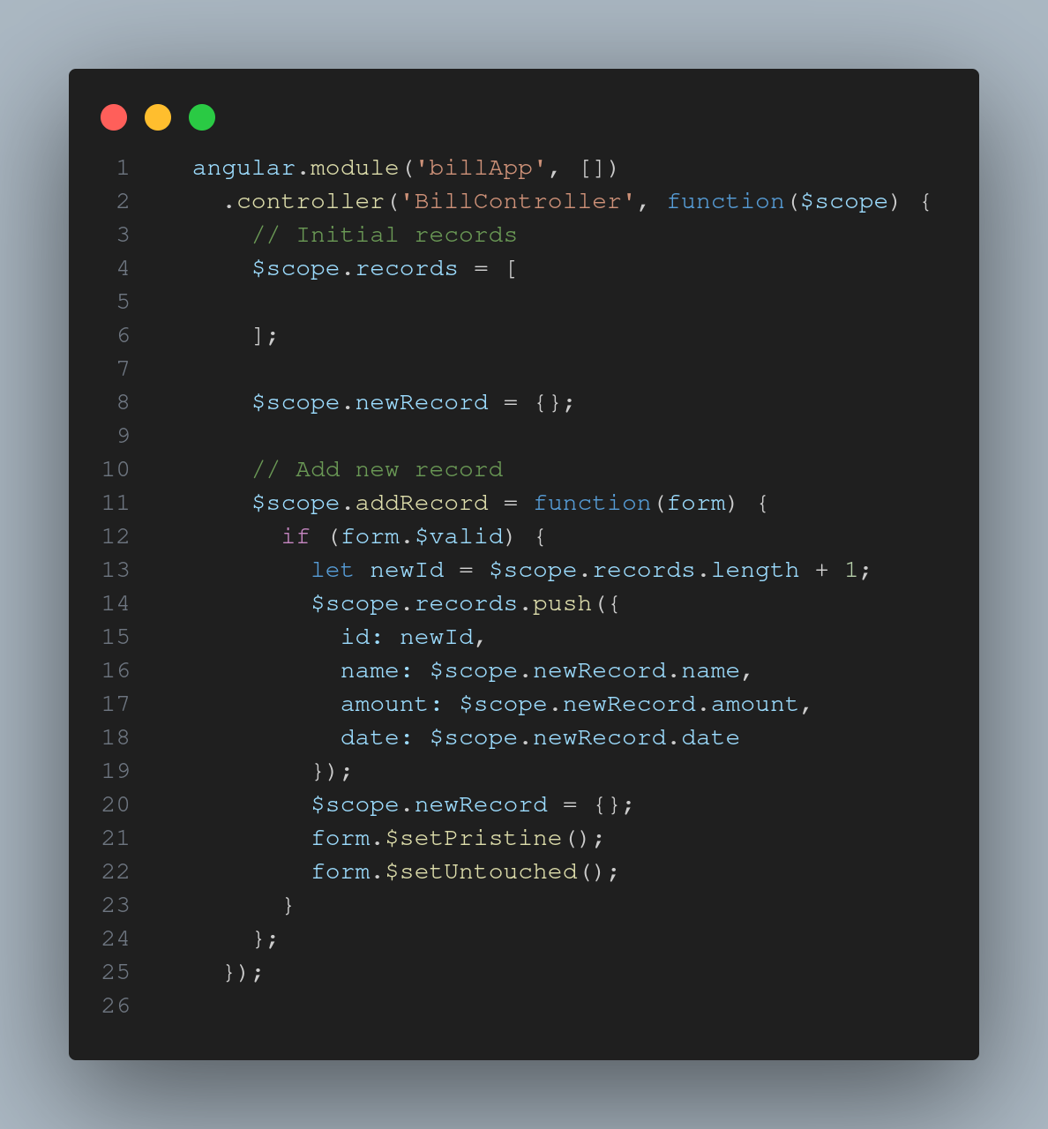 EXPERIMENT 4 OUTPUT 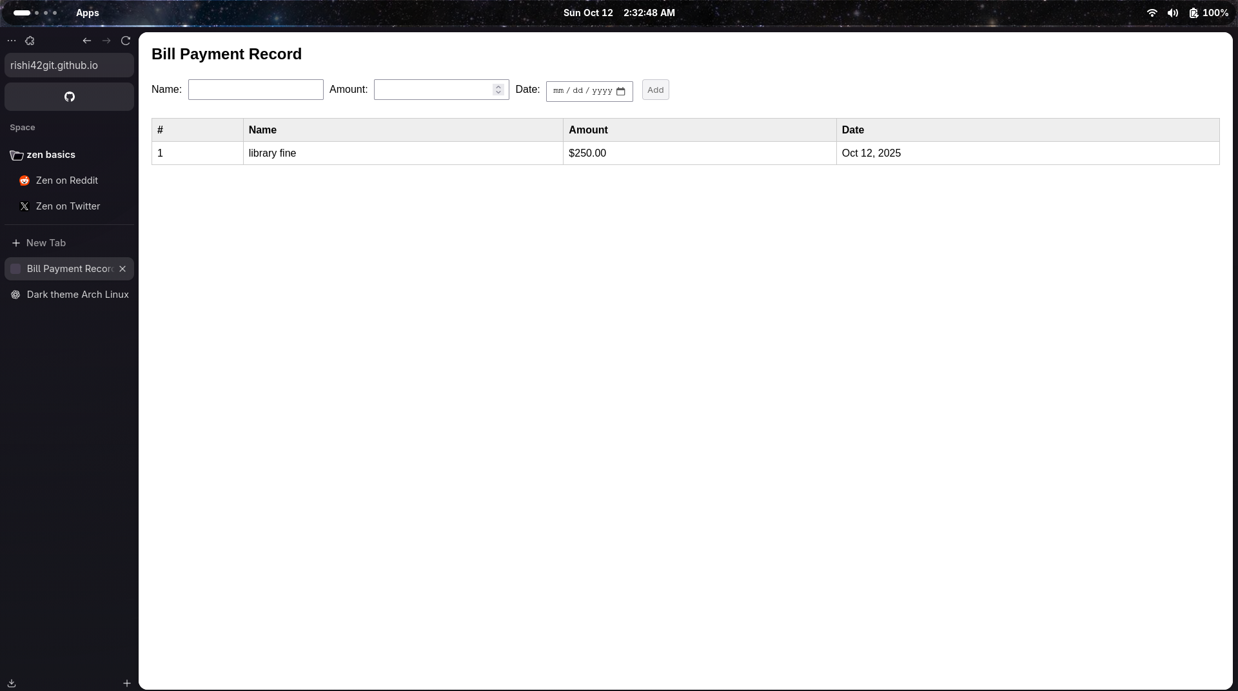

registration form EXPERIMENT 4.1 HTML 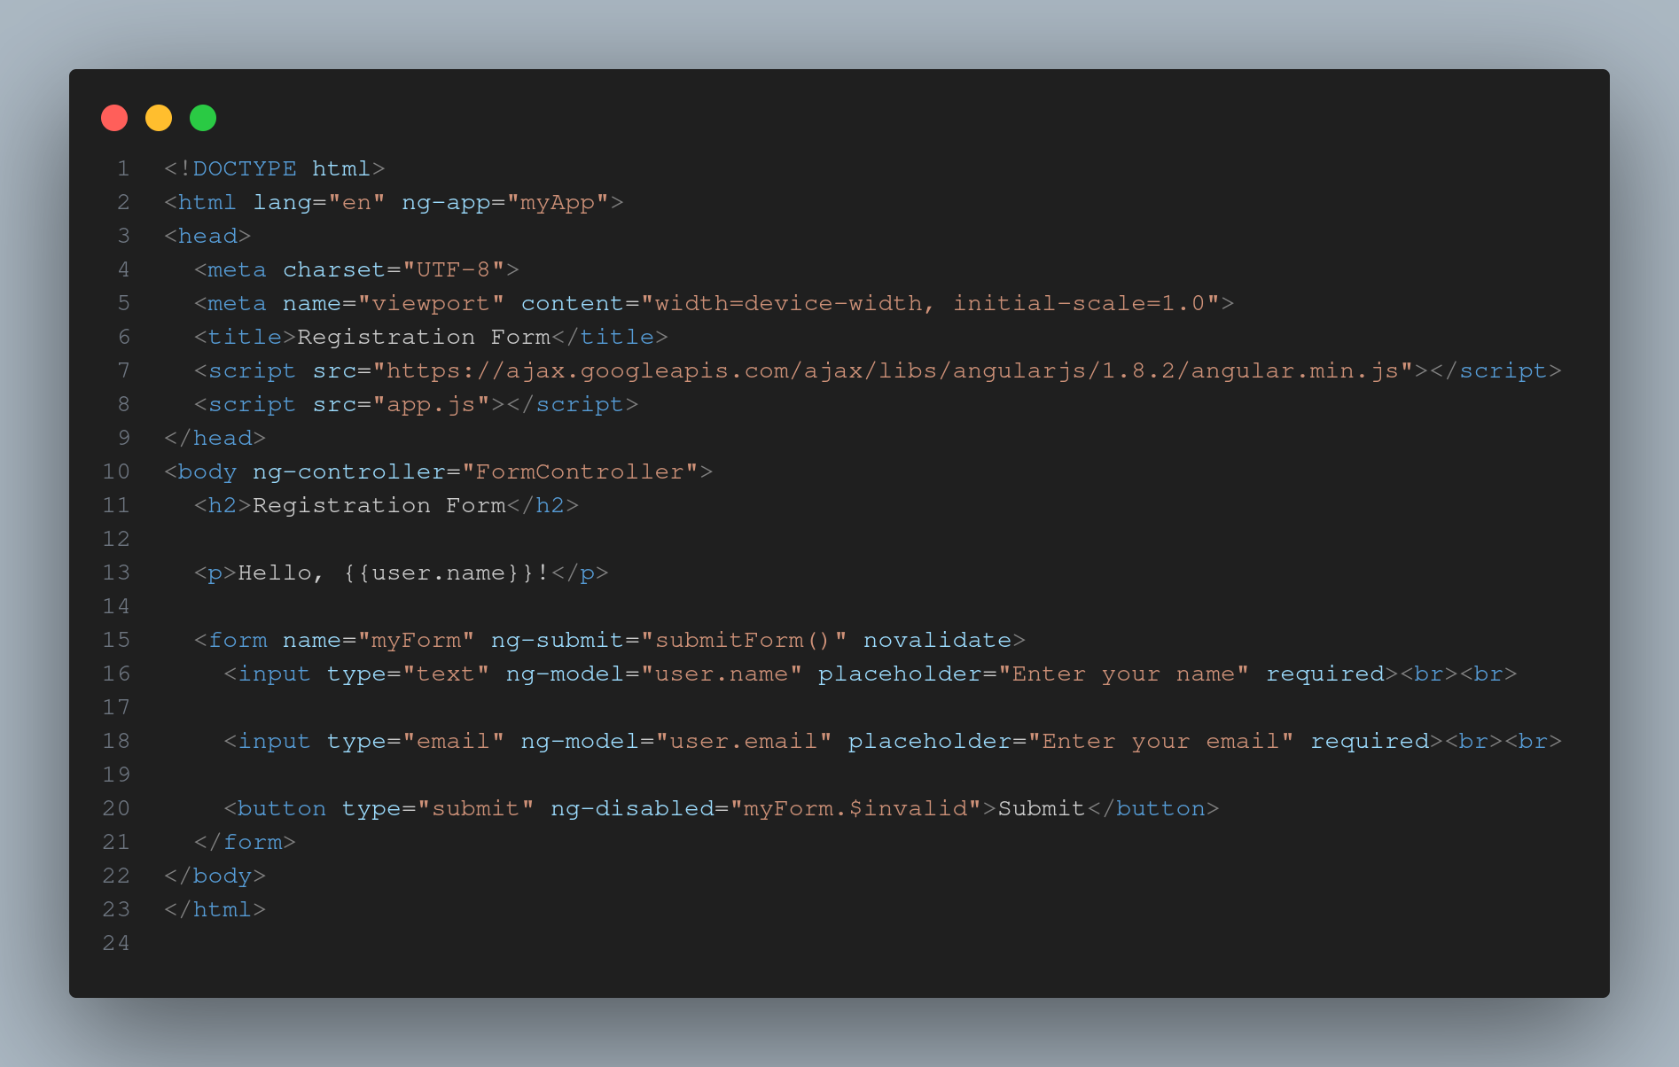 EXPERIMENT 4.1 CSS 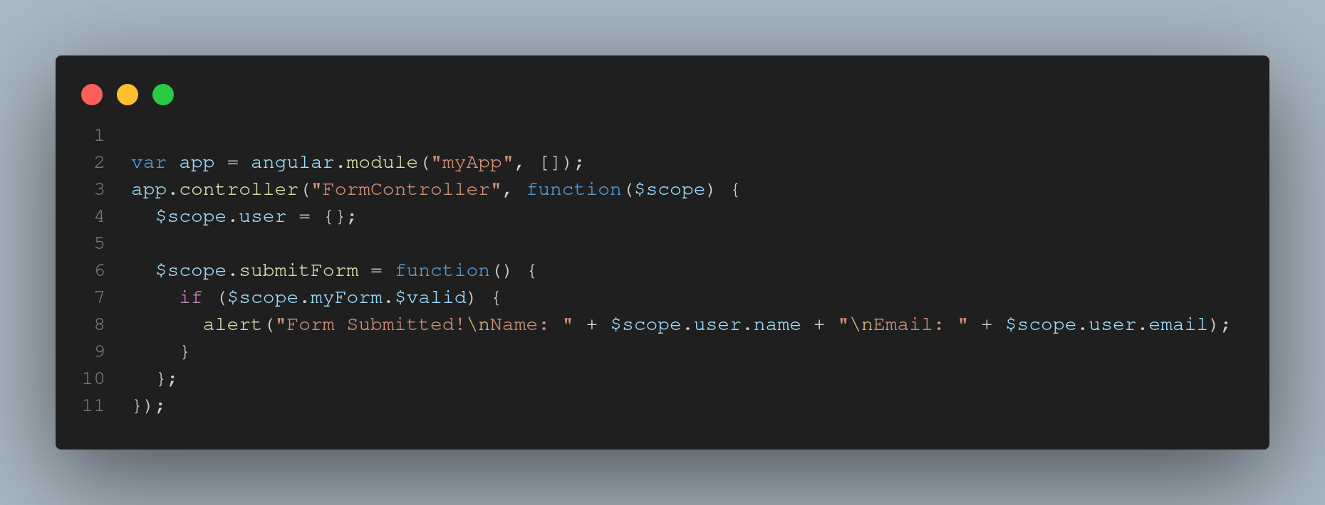 EXPERIMENT 4.1 OUTPUT 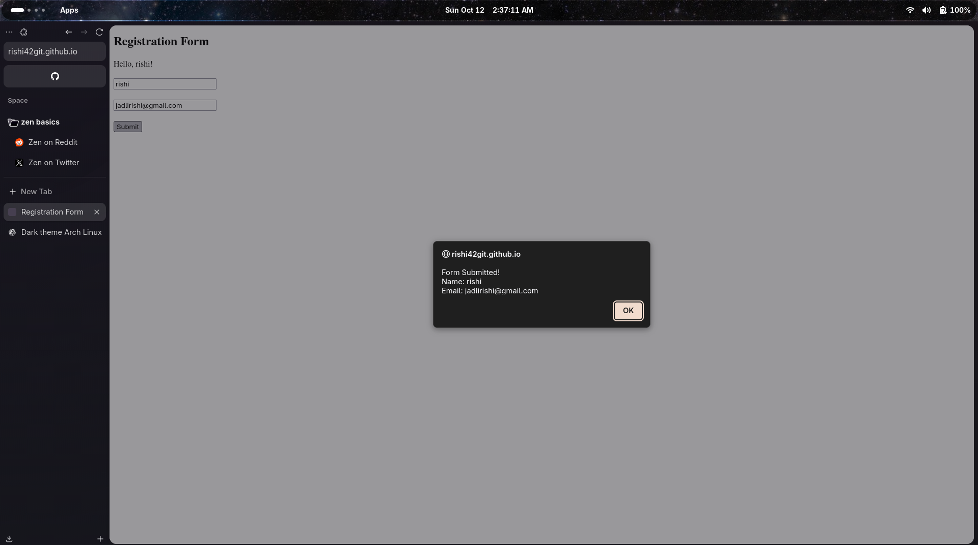 —

## Experiment 5 – jQuery Effects & DOM Traversal

## Experiment 6 – Node.js Basics

**Files:** exp5/index.html, exp5/exp5.css, exp5/exp5.js **Files:** exp6/test1.js, exp6/test2.js

**Objective:**  
Use jQuery to simplify DOM operations and add visual effects. Understand the basics of Node.js and JavaScript execution outside the browser.

**What I Learned:** - Using jQuery selectors ($() syntax). - Applying effects like hide(), show(), fadeIn(), and slideToggle(). - Traversing DOM elements efficiently. - Creating and running .js files with Node. - Using console.log(), modules, and basic I/O. **Challenges Faced:**  
- Understanding jQuery chaining and loading it before script execution.

**Skills Gained:**  
Simplified DOM handling — *“Write less, do more!”* EXPERIMENT 5_6 SERVER 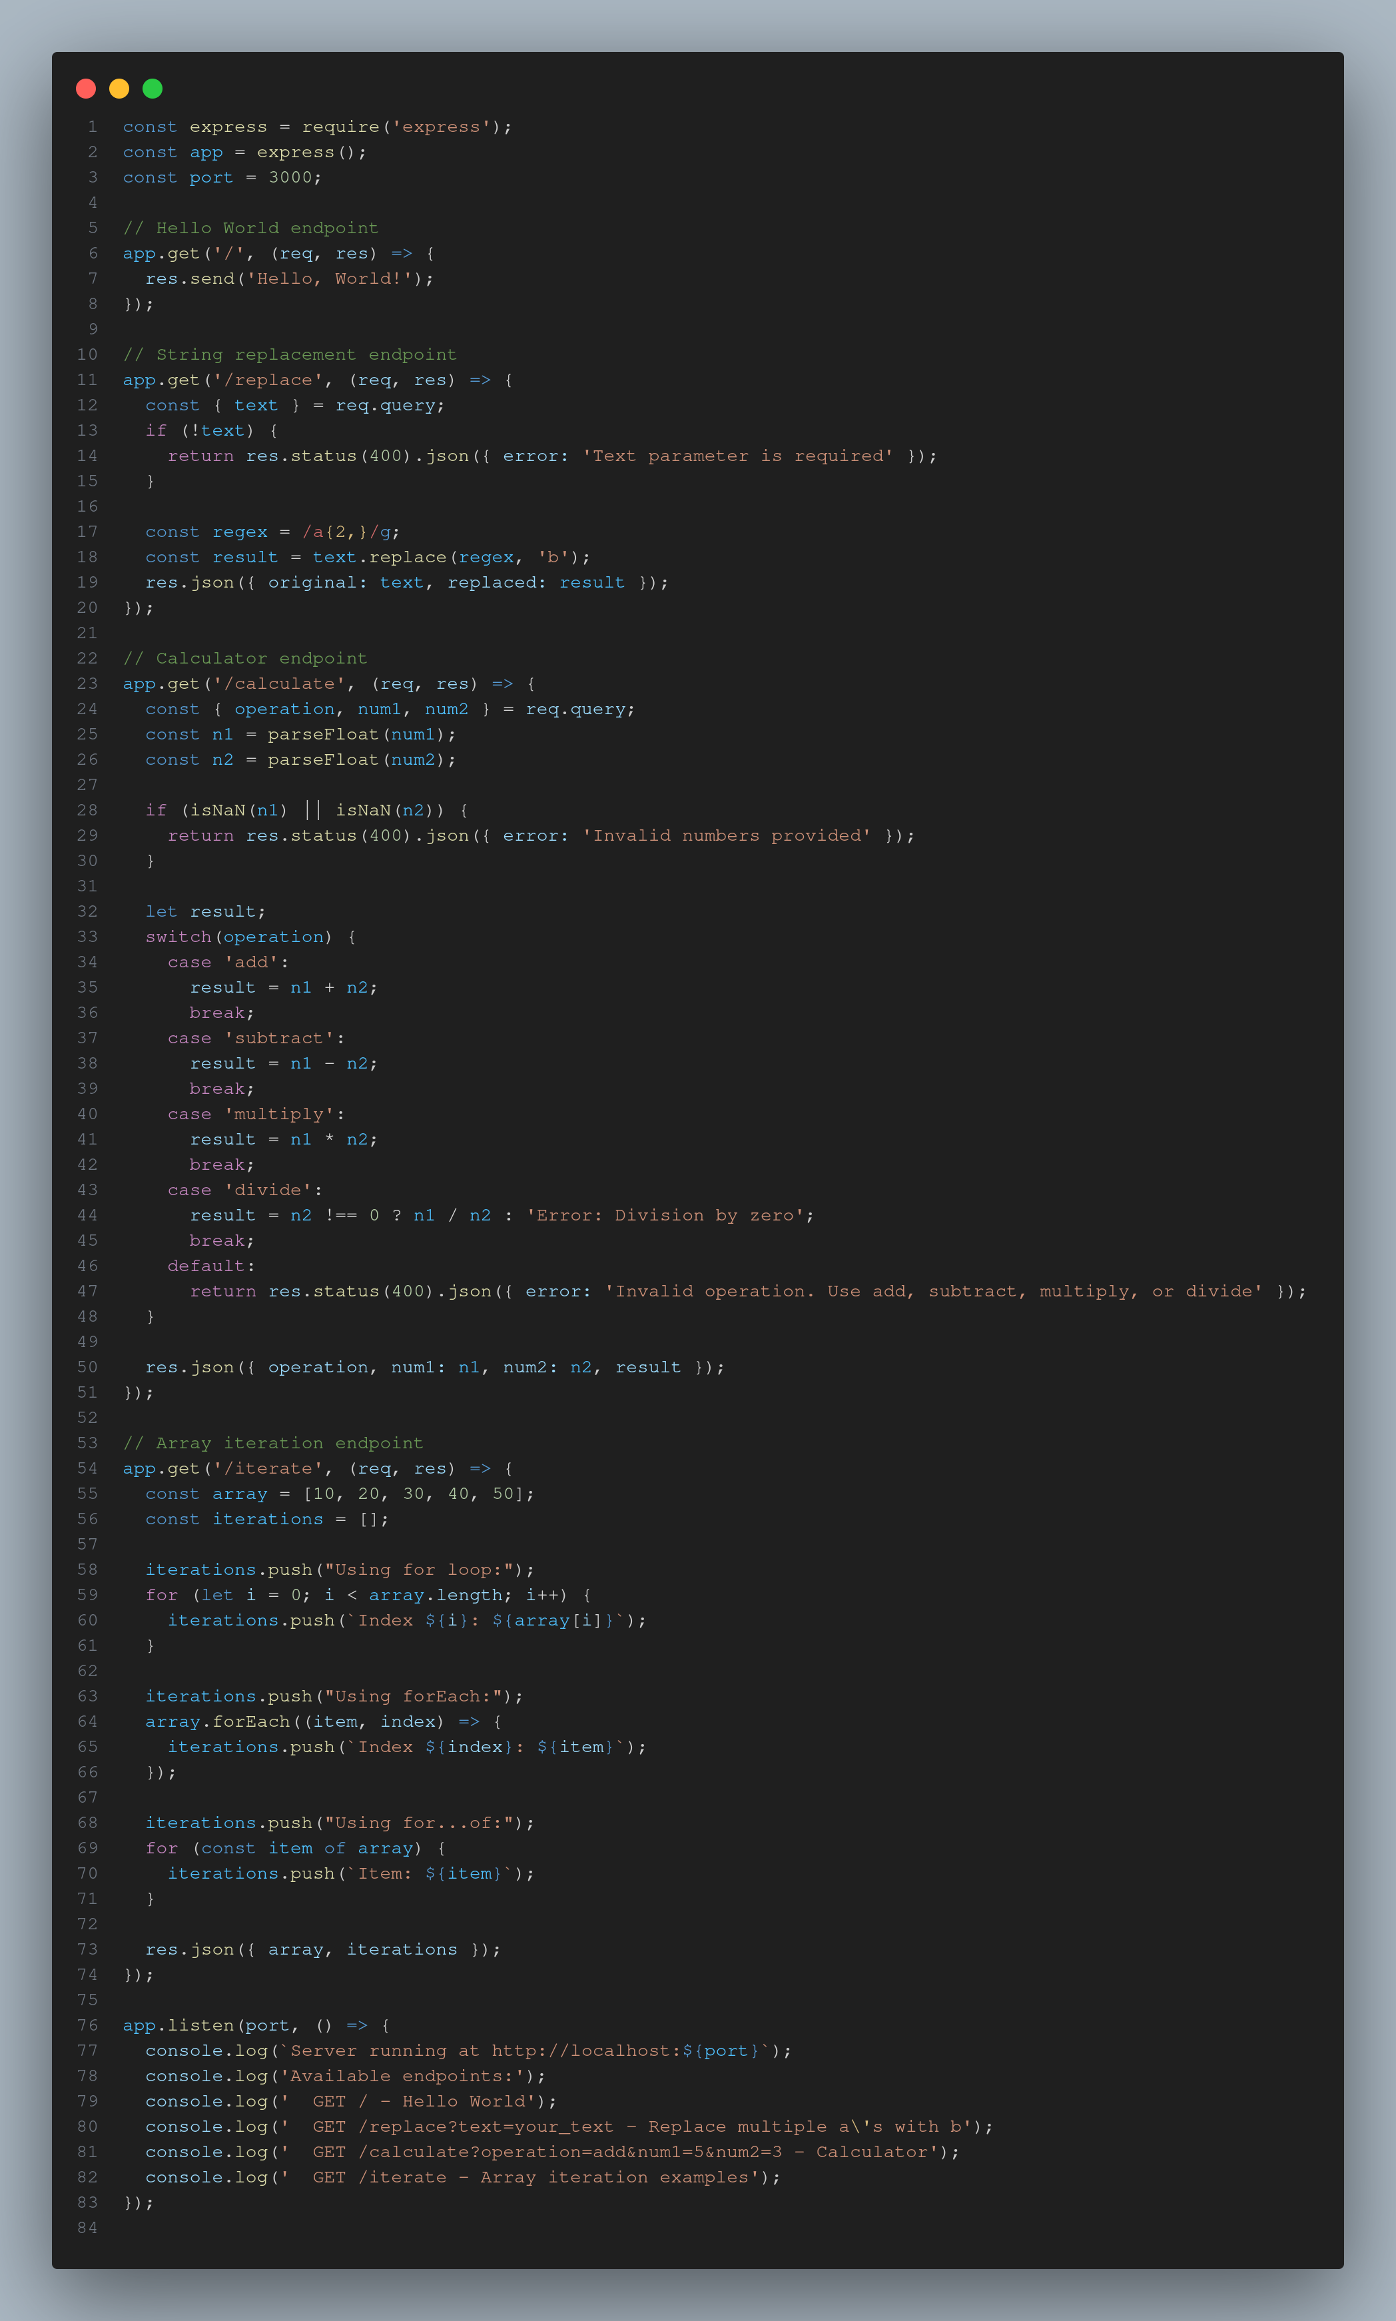 EXPERIMENT OUTPUT 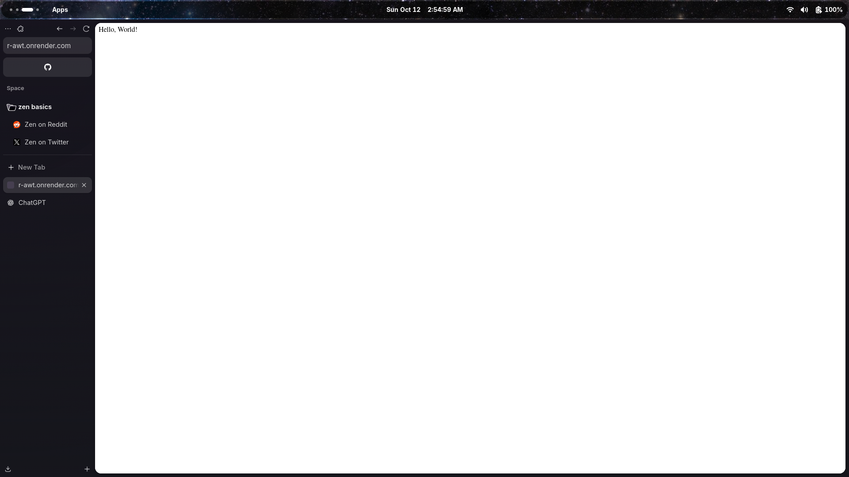 EXPERIMENT OUTPUT 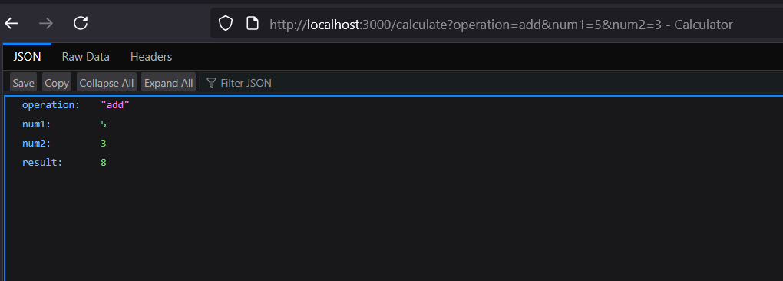 —

## Experiment 7 – Express Application

**Files:**  
- exp7/server.js  
- exp7/public/index.html, style.css, app.js  
- exp7/package.json

**Objective:**  
Build a small web application using **Express.js**.

**What I Learned:** - Setting up an Express server. - Serving static files from the public/ directory. - Handling basic routes and responses.

**Challenges Faced:**  
- Configuring Express routing and managing dependencies via npm. EXPERIMENT 7 : COOKIES 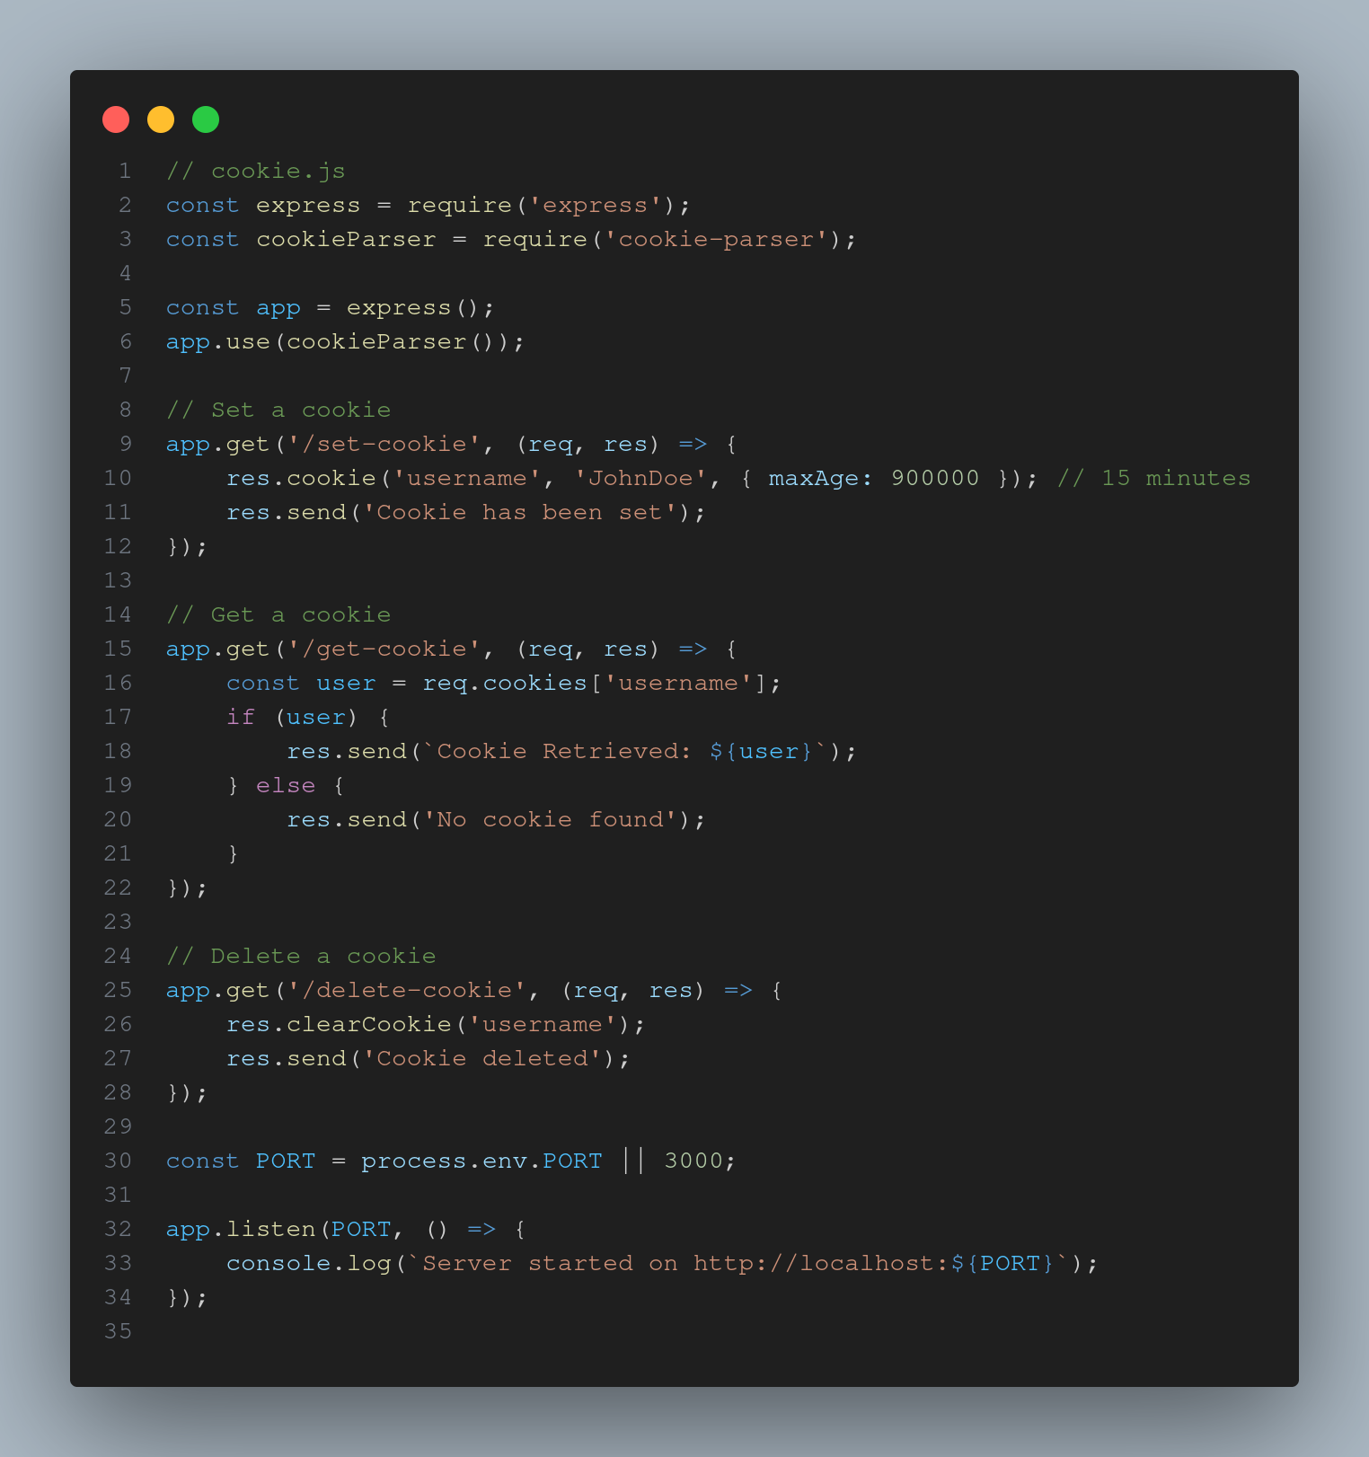 OUTPUT 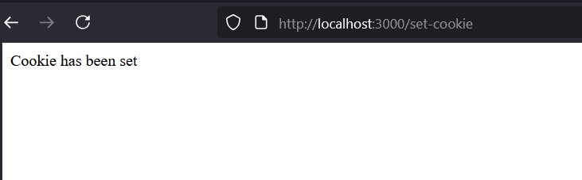 COOKIE RETRIEVAL 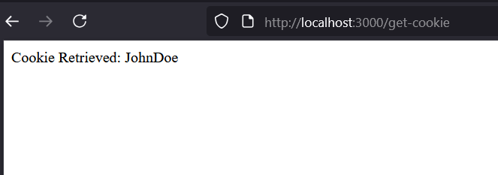 EXPERIMENT 7.2 SERVER 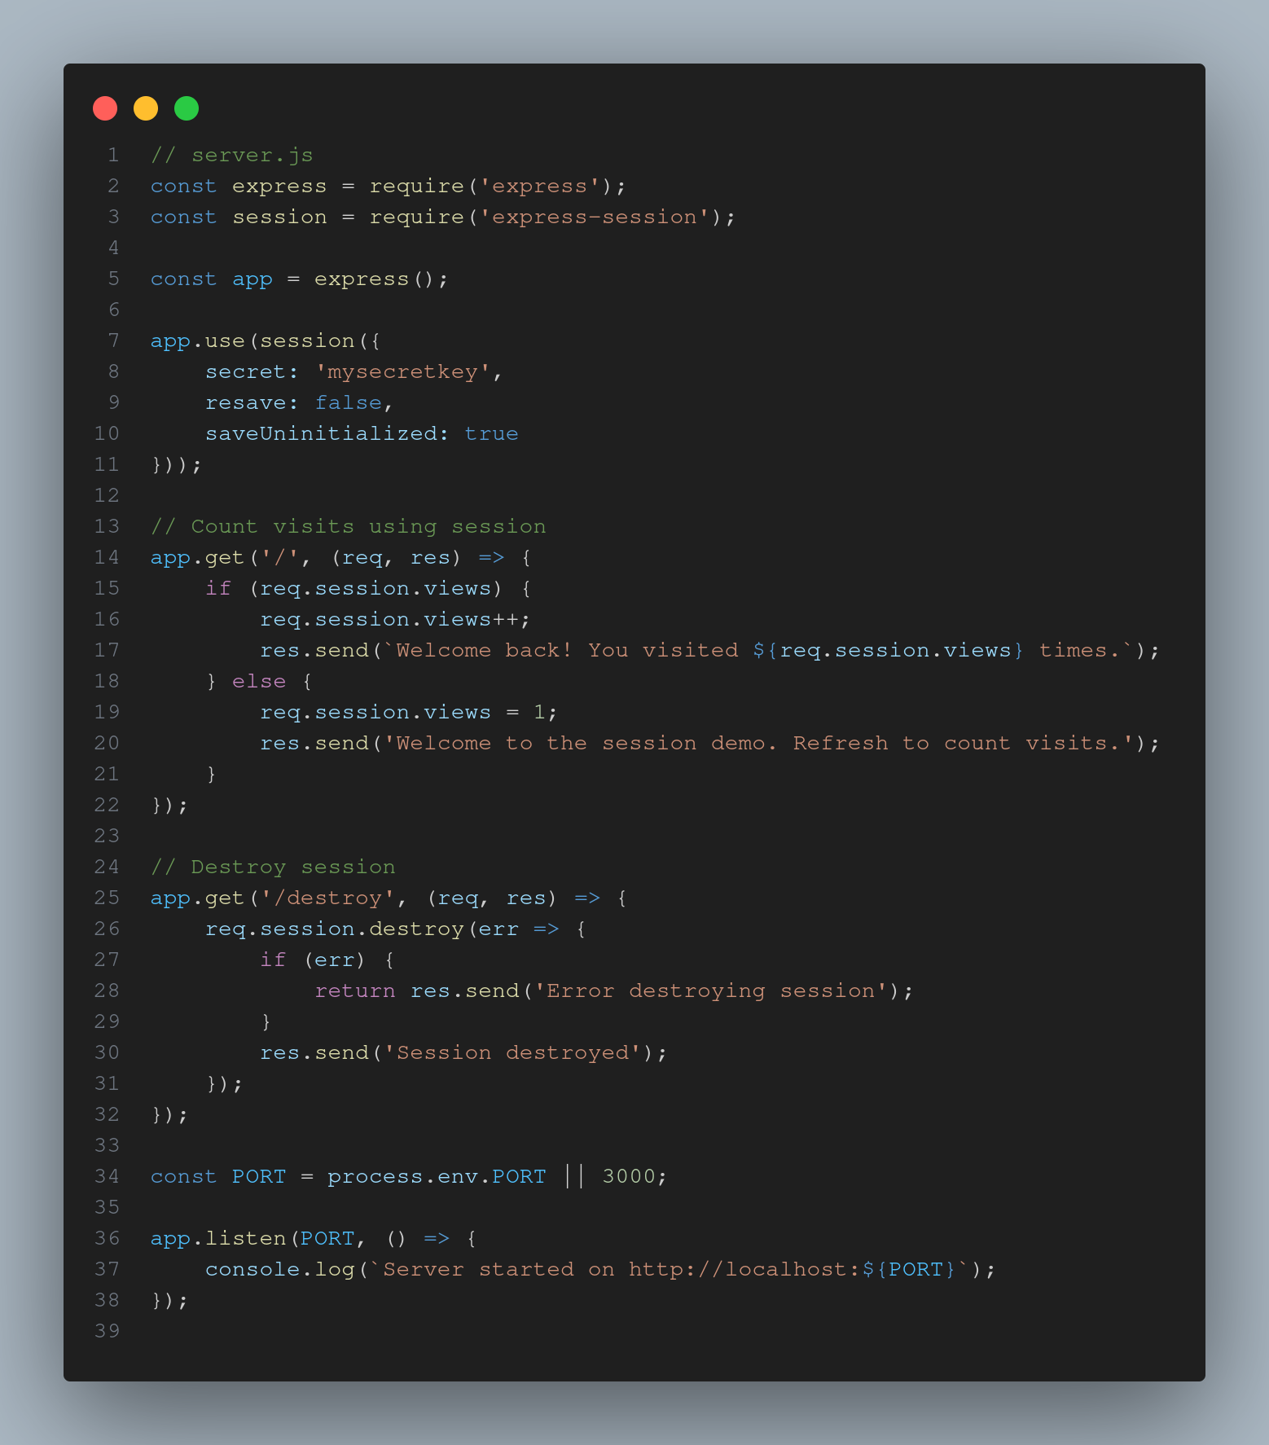 EXPERIMENT 7 SESSION COUNT 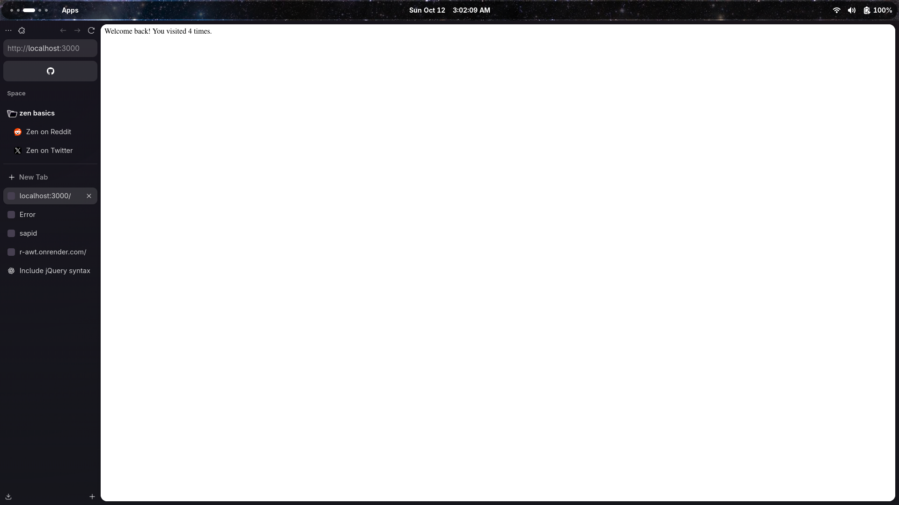 EXPERIMENT 7 SESSION DESTROY 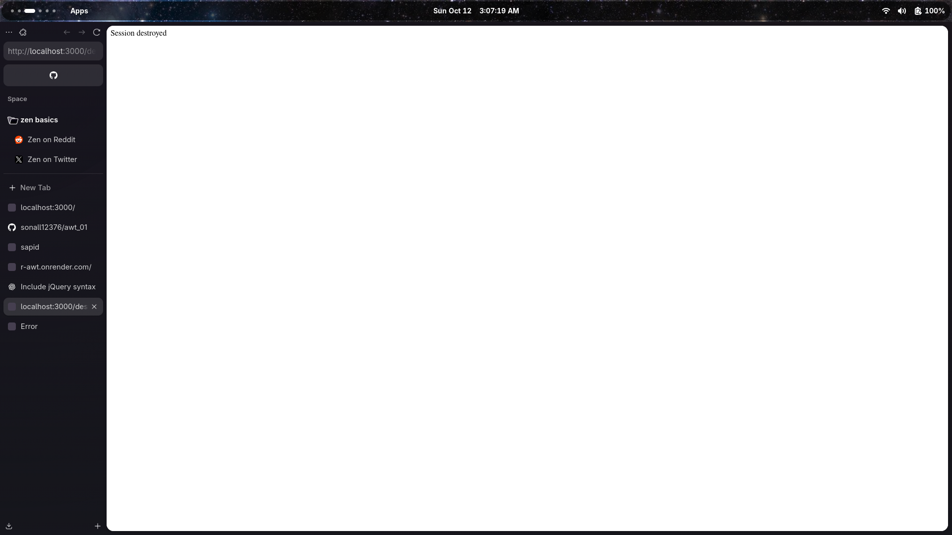

**Run Instructions:** ```bash cd exp7 npm install node server.js